MACIEJ ZIELINSKI
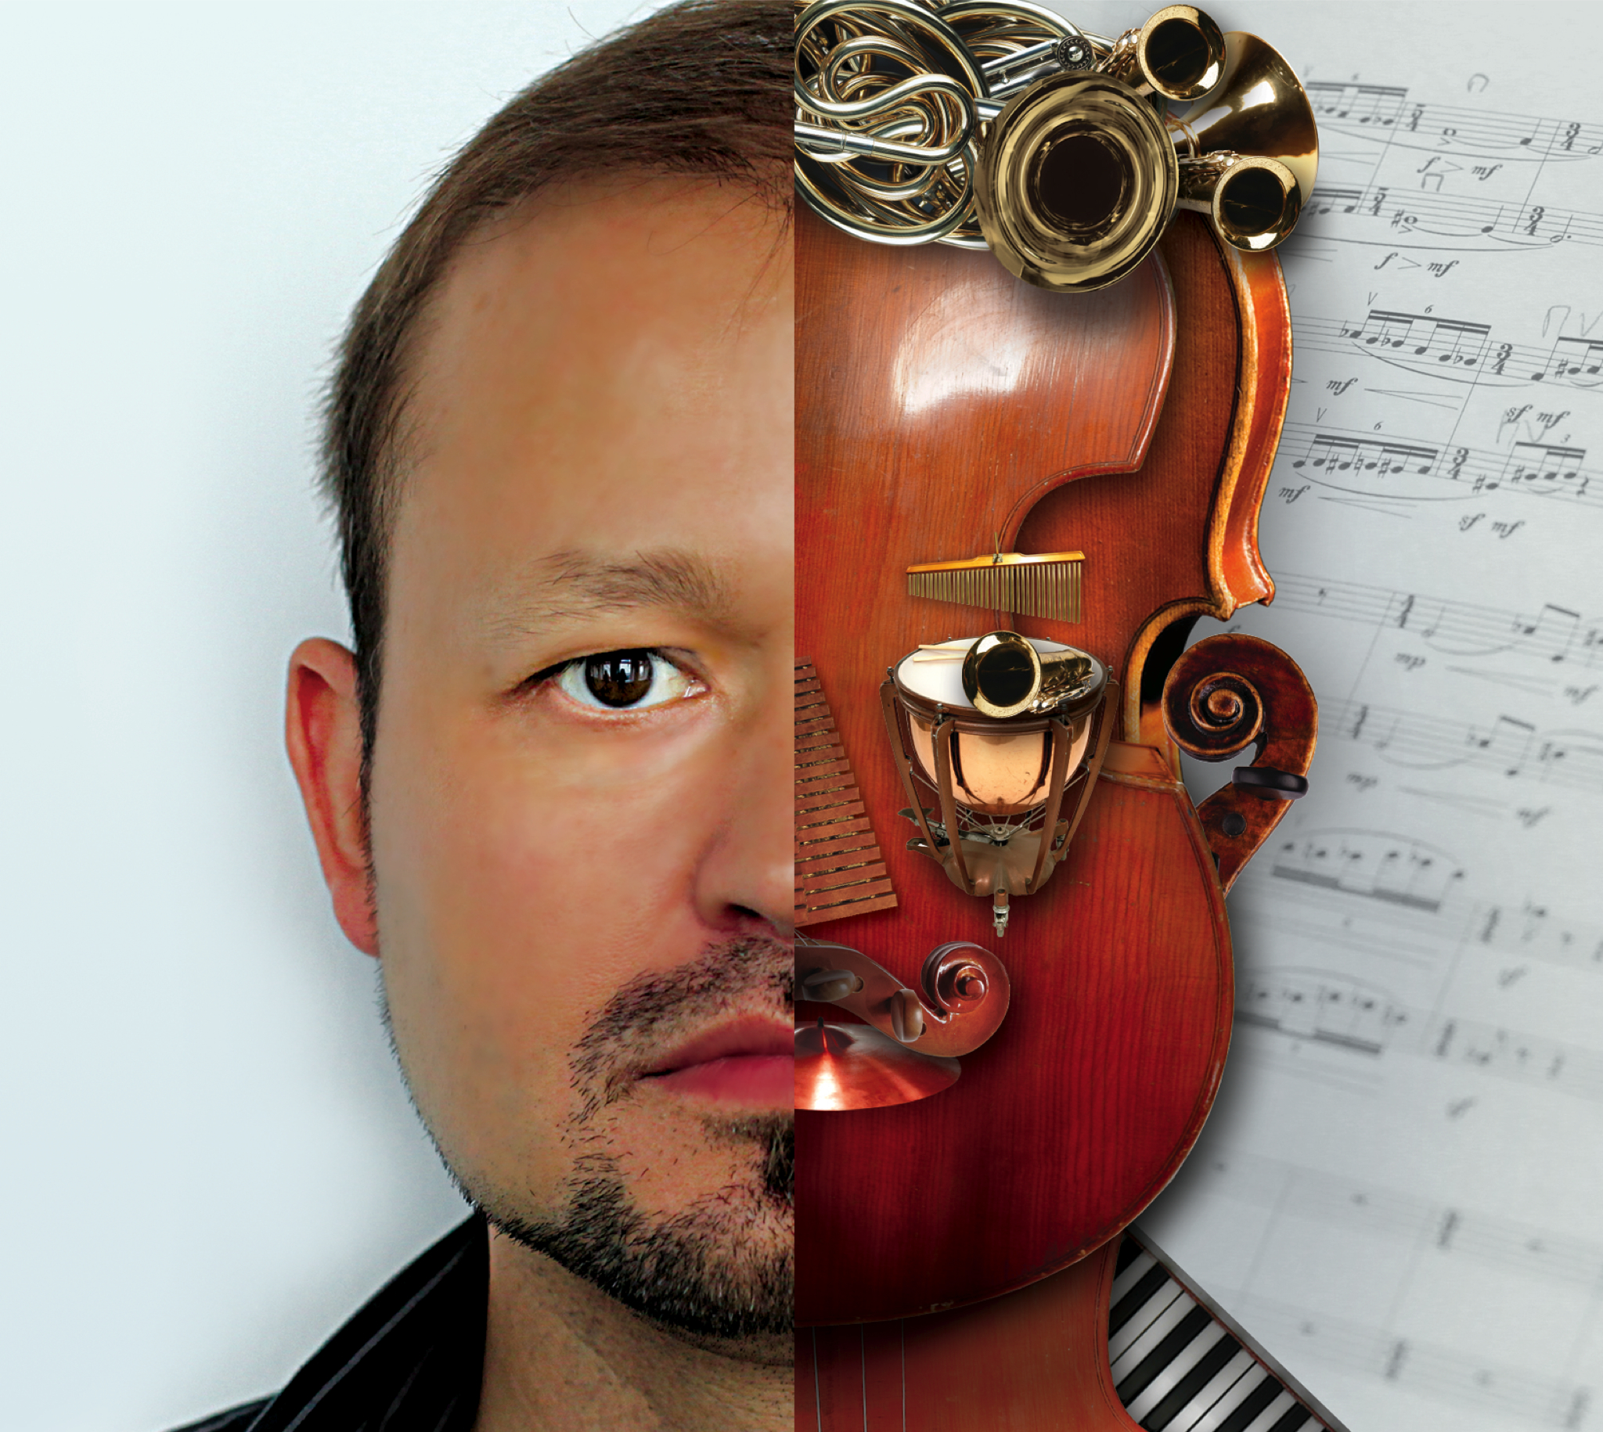
Maciej Zielinski is one of the most outstanding Polish composers of his generation. His compositions are well known for their expressiveness, textural and formal invention, and individual postmodern approach. His music is highly sought after by critics, performers and the audiences, being frequently performed at major contemporary music events.
Maciej Zielinski studied composition at the Frederic Chopin Music Academy in Warsaw and at the Royal Academy of Music in London.
His works have been featured in major contemporary music festivals including: the Warsaw Autumn Festival, the Poznan Spring Festival, the Musica Polonica Nova in Wrocław, the Park Lane Festival in London (UK), the World Music Days (Romania), and Presteigne Festival (Wales).
His music has been released on nearly 30 albums. In 2003 the album featuring String Quartet No. 1 won ‘Frederic’ the Polish Music Industry Award. In 2012 he was nominated for ‘Frederic’ Award in the category "Composer of the Year" (with distinguish co-nominees: K. Penderecki and W. Kilar). In 2014 his album “V Symphony” was nominated for ‘Frederic’ Award in the category “Best Album of the Year”.
His compositions have been awarded at 8 musical contests, including two internationals (in Czech Republic and Germany).
Maciej Zielinski is also an award-winning film music composer.

More: www.polishcomposer.com
Selected works:
3 Dreams and a Lullaby for cello and piano (2020)
Impressioni Concertante for wind quintet (2020)
Time Capsule for symphonic orchestra (2018)
Accello Tanguero for cello, accordion, string orchestra and percussion (2016)
That time of year for six voices (2016)
Sonore for orchestra (2015)
Violincerto for violin and chamber orchestra (2014)
Between Yesterday and Tomorrow for flute, viola and harp (2013)
Concello for cello and string orchestra (2013)
“V” Symphony (2012)
Barocode I for violin, viola and string orchestra (2011)
Concerto Inquieto for clarinet and orchestra (2010)
Shining for string orchestra (2006)
Trio for M.B. for clarinet, violin and cello (2004)
Sololis for solo piano (2004)
Fallen Angel for percussion and tape (2003)
Oratio for solo organ (2000)
Brass Quintet (1999)
Lutosławski in memoriam for oboe and piano (1999)
Capriccio for chamber orchestra (1998)
Abruzzo – Imaginary Landscape for chamber orchestra (1997)
Symphony No. 1 (1996)
- for alto saxophone and piano (1996)
Shining for string orchestra (1996)
Tractus for unaccompanied mixed choir (1996)
Three Phrases for clarinet, trombone, cello and piano (1996)
Piano Concerto No. 1 (1995)
Clouds for tape (1995)
Capriccio for solo violin (1995)
Domine, quis habitabit for unaccompanied mixed choir (1995)
Alone in a Crowd… for alto saxophone and tape (1994)
Vox Humana for percussion and amplified cello (1994)
String Quartet No. 1 (1994)
Musica per archi A.D. 1993 (1993)
Sonata for accordion (1993)
Capriccio for clarinet and piano (1993)
Perchoir for mixed choir and percussion (1992–93)
Miniatures for chamber orchestra (1992)
Variations for solo clarinet (1991)
Concertino for clarinet and piano (1991)
Miniature for string quartet (1989)

